Generate JS Objects from Excel sheet

* Open terminal in project source code

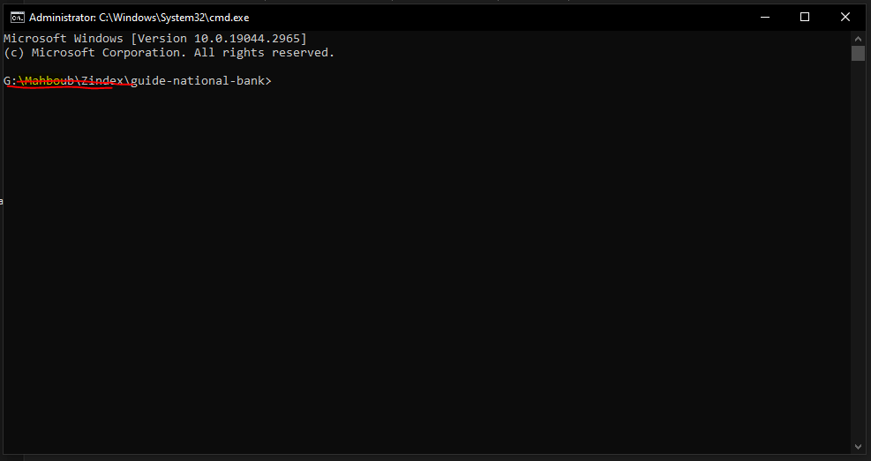

* run npm run generate:sheet <filename> where <filename> is the name of the excel sheet (.xlsx) you need to generate from. Needs to be next to "src" directory.

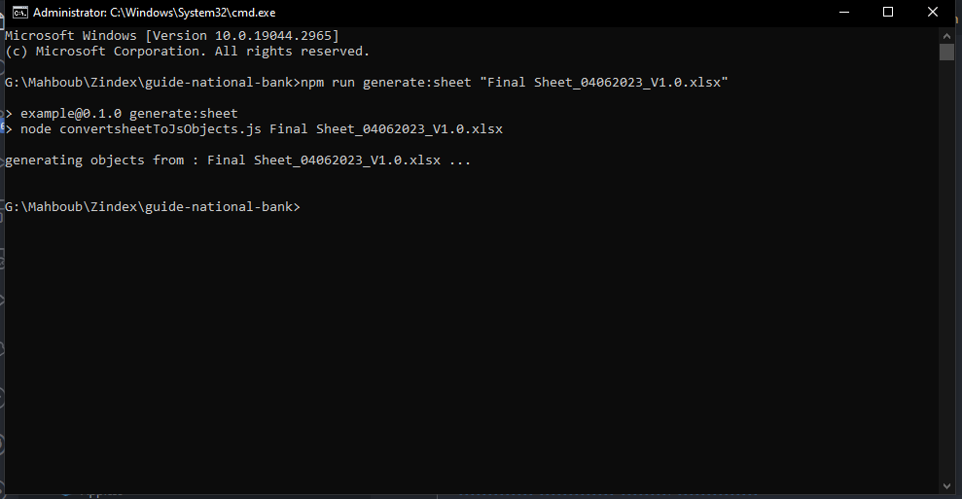

Files that will be affected

* src\pages\TrainingPlan
  + Skills.js
  + Behavior.js
  + Government.js
  + Future.js
  + Technology.js
* Src\pages\Registr
  + Selectors.js

Constraints on the Excel sheets

* Names of sheets columns should be exact as the following (including spaces)
  + "اسم البرنامج"
  + "مدة البرنامج"
  + "طريقة الحضور"
  + "وصف واضح للبرنامج يعكس طبيعته و العائد المرجو من حضوره"
  + "المستوي الوظيفي المستهدف "
  + "ملاحظات"
  + "الكفاءات الوظيفية التي يغطيها البرنامج "
  + "Pillar "
  + "Group"
  + "Unit"
  + "link "

Generate build

* npm run build
* In build/index.html, change all /static to ./static
* Move index.css and woff files from build/fonts to build
* Include build/index.css in build/index.html
* Change other /x links in build/index.html <head> to ./x
* Change t.p="/" or n.p="/" to t.p="" or n.p="" in build/static/js/main.<\*>.js